SPhO 2006-2009 Solutions
SPhO 2006
1) The beaker is most stable when $y$ is minimised. When the beaker is filled with water to depth $x$, one has the relation
$y=\frac{mh+(ρπr^{2}x)(x/2)}{m+ρπr^{2}x}$
The above is the general relation between $x$ and $y$. However, we seek to find a simplified relation in the situation that minimises $y$. This is achieved when:
$\frac{dy}{dx}=\frac{\left(m+ρπr^{2}x\right)⋅ρπr^{2}x-\left(mh+\left(ρπr^{2}x\right)\left(x/2\right)\right)⋅ρπr^{2}}{{\left(m+ρπr^{2}x\right)}^{2}}=0$
which simplifies to
$x-h+\frac{ρπr^{2}x^{2}}{2m}=0$
Solving the quadratic equation (and rejecting the negative root):
$x=\frac{m}{ρπr^{2}}(\sqrt{1+\frac{2ρπr^{2}h}{m}}-1)$
We rearrange the third equation to get $\frac{ρπr^{2}}{m}=\frac{2\left(h-x\right)}{x^{2}}$, and sub into the first:
$y=\frac{2h-x}{1+\frac{2\left(h-x\right)}{x}}=x=\frac{m}{ρπr^{2}}(\sqrt{1+\frac{2ρπr^{2}h}{m}}-1)$
with the relationship $y=x$.

2a) Consider a rope fragment wrapping an angle of $dθ$. By considering $F_{net}=0$ in the radial direction, one has $Tsinsin dθ ≈Tdθ=N$; by considering $F_{net}=0$ in the tangential direction, one has $dT=-μN=-μTdθ$. Thus:
$\frac{dT}{dθ}=-μT∴T=T_{0}e^{-μθ}$
Where $T_{0}$ is the tension on the end tied to the more massive weight. This shows that the support mass needed (proportional to the tension of the free end) depends exponentially on the angular length of the string, which is in turn proportional to the number of turns.

2b) $θ=\frac{1}{μ}lnln \frac{T_{0}}{T_{free}} =\frac{1}{μ}lnln \frac{M_{0}}{M_{free}} =\frac{1}{0.05}lnln \frac{100}{1} =92.1 rad=\frac{92.1}{2π}=14.7 rounds$

3) Newton’s law, $F=mg=\frac{d}{dt}\left(mv\right)=m\frac{dv}{dt}+v\frac{dm}{dt}$. Dividing by the proportionality constant in $m∝x$, one has:
$xg=x\frac{d^{2}x}{dt^{2}}+{\left(\frac{dx}{dt}\right)}^{2}$
Solving the differential equation (think simple! try polynomial solutions), one has $x=\frac{gt^{2}}{6}$. Thus
$m=kx=\frac{kgt^{2}}{6}=\frac{2⋅9.81⋅{0.5}^{2}}{6}=0.8175 g$
4) An exercise for the reader to show that for refractive index linearly varying in the y-direction, light travels in a circular arc with centre of circle lying on the x-axis corresponding to a refractive index $n=0$.
By drawing out the geometry of the problem, we get that when $α>0$, one can theoretically see infinitely far on flat ground, while when $α<0$, one can see as far as the ray that hits tangent to the ground; the radius of the circular arc of the light path will thus be $R=\frac{1}{\left|α\right|}$, and maximum viewed distance
$d=\sqrt{R^{2}-{\left(R-1.7\right)}^{2}}=1505.5 m$
At higher temperatures, density of air will be lesser and thus refractive index will also decrease (since intuitively, there is less resistance to photon travel). Since $α<0$, thus refractive index decreases with increasing height, thus temperature increases with increasing height.

5) Initial Capacitance $C_{0}=\frac{ε_{0}A}{d}$, initial potential difference $V_{0}=V$.
Intermediate Capacitance $C_{1}=\frac{3ε_{0}A}{d}$, intermediate potential difference $V_{1}=V$, charge $Q_{1}=C_{1}V_{1}=\frac{3ε_{0}A}{d}V$.
Final Capacitance $C_{2}=\frac{ε_{0}A}{d}$, final charge $Q_{2}=Q_{1}=\frac{3ε_{0}A}{d}V$.
$ΔE=E_{f}-E_{i}=\frac{Q_{2}^{2}}{2C_{2}}-\frac{1}{2}C_{0}V_{0}^{2}=4\frac{ε_{0}A}{d}V^{2}$
6) Let circular course have radius $R$. One has that:
$T=\int_{0}^{2π}{}\frac{Rdθ}{V}=\frac{2πR}{V}$
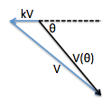
One also has that after the wind is blowing, $V^{2}=k^{2}V^{2}+V_{θ}^{2}+2kVV_{θ}coscos θ$ and by solving the quadratic equation, one has
$V_{θ}=\sqrt{k^{2}V^{2}θ +\left(1-k^{2}\right)V^{2}}-kVcoscos θ =V\left(\sqrt{1-k^{2}θ }-kcoscos θ \right)=V\left(1-kcoscos θ -\frac{1}{2}k^{2}θ +O\left(k^{4}\right)\right)$
$T_{wind}=\int_{0}^{2π}{}\frac{Rdθ}{V_{θ}}=\int_{0}^{2π}{}\frac{Rdθ}{V\left(1-kcoscos θ -\frac{1}{2}k^{2}θ +O\left(k^{4}\right)\right)}=\frac{R}{V}\int_{0}^{2π}{}\left(1+kcoscos θ +k^{2}\left(1-\frac{1}{2}θ \right)+O\left(k^{3}\right)\right)=\frac{R}{V}\left(2π+k^{2}\left(2π-\frac{π}{2}\right)\right)=\frac{2πR}{V}\left(1+\frac{3}{4}k^{2}\right)$
Increase in time: $ΔT=\frac{3}{4}k^{2}T$

7) (i) While it is hard to visualise, it helps to draw the circuit diagram:
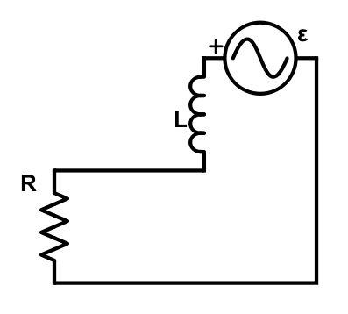
Here, the emf is $ε=\frac{dϕ}{dt}=\frac{d}{dt}\left(Φ_{0}coscos ωt \right)=-Φ_{0}ωsinsin ωt$
And because the rotation of the bicycle wheel is periodic, thus $ω=\frac{v}{r}$.
(we can separate the emf due to self-inductance and emf due to external magnetic flux)
One approach is to use impedance. Using $ε=Φ_{0}ie^{iωt}$:
$Z_{total}=R+iωL=R+iωL$
$∴I=\frac{ε}{Z_{total}}=\frac{Φ_{0}ωie^{iωt}}{R+iωL}=\frac{Φ_{0}ωe^{iωt}}{ωL-iR}=\frac{Φ_{0}ωe^{iωt}}{\sqrt{R^{2}+ω^{2}L^{2}}e^{iarctanarctan \frac{-R}{ωL} }}=\frac{Φ_{0}ωe^{i\left(ωt+arctanarctan \frac{R}{ωL} \right)}}{\sqrt{R^{2}+ω^{2}L^{2}}}$
therefore
$I=I_{0}coscos \left(ωt+ϵ\right) , I_{0}=\frac{Φ_{0}ω}{\sqrt{R^{2}+ω^{2}L^{2}}}=\frac{Φ_{0}}{\sqrt{R^{2}r^{2}/v^{2}+L^{2}}},tantan ϵ =\frac{R}{ωL}=\frac{Rr}{vL}$
Another method is to solve the equation directly:
$IR+L\frac{dI}{dt}-Φ_{0}sinsin ωt =0$
which will achieve the same result.
(ii)
$P=〈I^{2}R〉=I_{0}^{2}R〈\left(ωt+ϵ\right) 〉=\frac{1}{2}I_{0}^{2}R=\frac{Φ_{0}^{2}R}{2\left(R^{2}r^{2}/v^{2}+L^{2}\right)}<\frac{Φ_{0}^{2}R}{2L^{2}}$
where it can get arbitrarily close from below when $v→∞$.

8) (i) Typical maximisation problem (for a fixed mass number $A$):
${\frac{dM}{dZ}|}_{A}=0∴m_{p}-m_{n}-2a_{3}\frac{2\left(A-2Z\right)}{A}+2a_{4}\frac{Z}{A^{1/3}}=0$
$∴\left(8a_{3}+2a_{4}A^{2/3}\right)\frac{Z}{A}=m_{n}-m_{p}+4a_{3}$
which gives the expression as desired.
(ii) Mass-per nucleon $ρ=M/A$. Let $m_{p}=m_{n}=m$. Then
$ρ=\frac{M}{A}=\frac{Z}{A}m_{p}+\left(1-\frac{Z}{A}\right)m_{n}-a_{1}+a_{2}A^{-1/3}+a_{3}{\left(1-\frac{2Z}{A}\right)}^{2}+a_{4}\frac{Z^{2}}{A^{4/3}}$
$=m-a_{1}+a_{2}A^{-1/3}+a_{3}{\left(1-2λ\right)}^{2}+λ^{2}a_{4}A^{2/3}$
(when $Z$ is for maximum $M$) and again, solving the maximisation problem
${\frac{dρ}{dA}|}_{Z/A=λ}=0∴-\frac{1}{3}a_{2}A^{-4/3}+\frac{2}{3}λ^{2}a_{4}A^{-1/3}=0∴A_{s}=\frac{a_{2}}{2λ^{2}a_{4}}$
(ii) We know that the binding energy of a particle is
$BE\left(Z,A\right)=\left(M-Am\right)c^{2}$
(the energy-equivalent of the difference in mass of constituent nucleons and the mass of the nucleon, which is the energy necessary to construct the nucleus from its constituent nucleons) so the binding energy per nucleon is:
$X\left(Z,A\right)=\frac{BE\left(Z,A\right)}{A}=\left(ρ-m\right)c^{2}$
which is maximised when $ρ$ is maximum. The question says that iron is the element which maximises $ρ$, so
$56=A_{s}≈\frac{a_{2}}{2λ^{2}a_{4}}$
In order for spontaneous fission of a particle $\left(Z,A\right)$ into two equal fragments $\left(\frac{Z}{2},\frac{A}{2}\right)$, one must have that $2⋅BE\left(\frac{Z}{2},\frac{A}{2}\right)<BE\left(Z,A\right)∴X\left(\frac{Z}{2},\frac{A}{2}\right)<X\left(Z,A\right)$. Therefore one must have that
$ρ\left(\frac{Z}{2},\frac{A}{2}\right)<ρ\left(Z,A\right)$
and we fix that $Z=λA$:
$a_{2}{\left(\frac{A}{2}\right)}^{-1/3}+λ^{2}a_{4}{\left(\frac{A}{2}\right)}^{2/3}<a_{2}A^{-1/3}+λ^{2}a_{4}A^{2/3}$
we proceed to solve this inequality:
$a_{2}A^{-1/3}\left(2^{1/3}-1\right)<λ^{2}a_{4}A^{2/3}\left(1-2^{-2/3}\right)$
$A>\frac{\left(2^{1/3}-1\right)}{\left(1-2^{-2/3}\right)}⋅\frac{a_{2}}{λ^{2}a_{4}}=\frac{\left(2^{1/3}-1\right)}{\left(1-2^{-2/3}\right)}⋅2⋅56=78.6$
So we can predict that for mass numbers higher that Bromine, $A>79$, spontaneous fission into two equal fragments should occur.

We know that the speed of light in the bottom trough is $v_{b}=\frac{c}{n}$. In the inertial frame in which the water of the top trough is stationary, it is also $v_{t}^{'}=\frac{c}{n}$. The relativistic Doppler effect gives that the light is travelling in the lab frame at
$v_{t}=\frac{v_{t}^{'}+ν}{1+v_{t}^{'}ν/c^{2}}=\frac{c/n+ν}{1+ν/nc}=\frac{c+nν}{n+ν/c}$
The phase difference is thus
$ϕ=2πf\left(t_{b}-t_{t}\right)=\frac{2πc}{λ}\left(\frac{L}{v_{b}}-\frac{L}{v_{t}}\right)=\frac{2πcL}{λ}\left(\frac{n}{c}-\frac{n+ν/c}{c+nν}\right)=\frac{2πcL}{λ}\left(\frac{\left(n^{2}-1\right)ν}{c\left(c+nν\right)}\right)=\frac{2πL\left(n^{2}-1\right)ν}{λ\left(c+nν\right)}$
10) Compton scattering, see here for derivation
https://courses.physics.ucsd.edu/2015/Spring/physics4e/compton.pdf
$θ=90°∴λ^{'}-λ=\frac{h}{m_{e}c}∴\frac{c}{ν^{'}}-\frac{c}{ν}=\frac{h}{m_{e}c}∴\frac{c}{ν^{'}}=\frac{h}{m_{e}c}+\frac{c}{ν}=\frac{hν+m_{e}c^{2}}{m_{e}cν}$
$∴ν^{'}=\frac{m_{e}c^{2}}{hν+m_{e}c^{2}}ν$
Use $E=hν, E^{'}=hν^{'}$: ($m_{e}c^{2}=\frac{\left(9.11×{10}^{-31}\right){\left(2.997×{10}^{8}\right)}^{2}}{1.6×{10}^{-19}}=511.4 keV$
$E^{'}=\frac{m_{e}c^{2}}{E+m_{e}c^{2}}E=\frac{511.4}{50.0+511.4}⋅50.0=45.5 keV$
SPhO 2007
1) Let $a_{n}$ be the horizontal distance of the centre of mass (with respect to the edge of the table) of the $n^{th}$ block from the top. Then the right edge of the $n^{th}$ block from the top has distance $a_{n}+d_{0}$. Here, $d_{0}$ is the distance of the edge of the block from the centre of mass; for the blocks given, we can orientate the square such that a diagonal is perpendicular to the table edge, which gives us the maximum value for $d_{0}$ as $d_{0}=\sqrt{2}/2$.

For each $n$, the following must hold: the centre of mass of the top $n$ blocks must lie within the area of the ${\left(n+1\right)}^{th}$ block from the top; for $n=5$, the centre of mass of all $5$ blocks must lie behind the table edge. This gives us the following set of equations:
- $a_{1}≤a_{2}+d_{0} -\left(1\right)$
- $\frac{a_{1}+a_{2}}{2}≤a_{3}+d_{0} -\left(2\right)$
- $\frac{a_{1}+a_{2}+a_{3}}{3}≤a_{4}+d_{0} -\left(3\right)$
- $\frac{a_{1}+a_{2}+a_{3}+a_{4}}{4}≤a_{5}+d_{0} -\left(4\right)$
- $\frac{a_{1}+a_{2}+a_{3}+a_{4}+a_{5}}{5}≤0 -\left(5\right)$
and we are interested in maximising $d=a_{1}+d_{0}$.

The direct way to achieve this is
$\frac{1}{2}\left(1\right)+\frac{1}{3}\left(2\right)+\frac{1}{4}\left(3\right)+\frac{1}{5}\left(4\right)+\left(5\right):d≤d_{0}\left(1+\frac{1}{2}+\frac{1}{3}+\frac{1}{4}+\frac{1}{5}\right)$
with equality achieved at all inequalities when
- $a_{1}=d_{0}\left(1+\frac{1}{2}+\frac{1}{3}+\frac{1}{4}+\frac{1}{5}-1\right)$
- $a_{2}=d_{0}\left(\frac{1}{2}+\frac{1}{3}+\frac{1}{4}+\frac{1}{5}-1\right)$
- $a_{3}=d_{0}\left(\frac{1}{3}+\frac{1}{4}+\frac{1}{5}-1\right)$
- $a_{4}=d_{0}\left(\frac{1}{4}+\frac{1}{5}-1\right)$
- $a_{5}=d_{0}\left(\frac{1}{5}-1\right)$
So maximum overhang $d_{max}=\frac{\sqrt{2}}{2}\left(1+\frac{1}{2}+\frac{1}{3}+\frac{1}{4}+\frac{1}{5}\right)=\frac{77}{60}\sqrt{2}=1.82 m$

2) Drawing free-body diagrams:
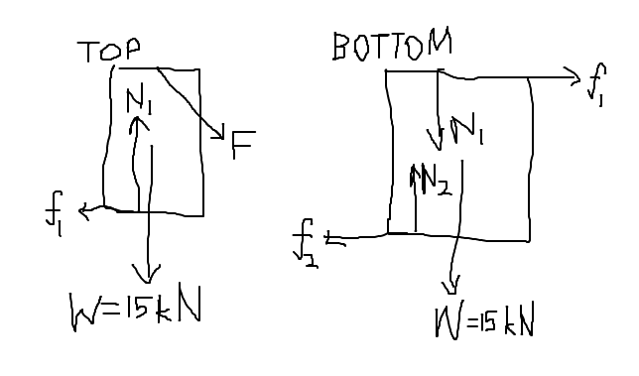
For the top block: $N_{1}=W+\frac{4}{5}F, f_{1}=\frac{3}{5}F∴μ_{M-M}=0.20≥\frac{f_{1}}{N_{1}}=\frac{3F}{5W+4F}$
For the 2-block system: $N_{2}=2W+\frac{4}{5}F, f_{2}=\frac{3}{5}F∴μ_{M-G}=0.15≥\frac{f_{2}}{N_{2}}=\frac{3F}{10W+4F}$
This gives $\{W≥2.2F 1.5W≥2.4F$
Therefore $F_{max}=W⋅\left\{\frac{1.5}{2.4},\frac{1}{2.2}\right\} =\frac{15}{2.2} kN=6.82 kN$

3) Drawing the free-body diagram of the person:
$F_{net\left(y\right)}=Mg-N=Masinsin θ ∴N=M\left(g-asinsin θ \right)$

4) (a) At maximum height, $v_{y}=0=v_{0}sinsin θ -gt∴t=\frac{v_{0}sinsin θ }{g}$
So height $H=\frac{1}{2}gt^{2}=\frac{1}{2}g{\left(\frac{v_{0}sinsin θ }{g}\right)}^{2}=\frac{v_{0}^{2}θ }{2g}$
Solutions from energy conservation also work (note x-velocity is constant).

(b) We know by conservation of momentum that $v_{y1}+2v_{y2}=0$ (where $v_{y1}>0,v_{y2}<0$) and
$v_{y1}t_{1}+\frac{1}{2}gt_{1}^{2}=h -\left(1\right)$
$v_{y2}t_{2}+\frac{1}{2}gt_{2}^{2}=h -\left(2\right)$
so
$t_{2}\left(1\right)+2t_{1}\left(2\right):\frac{1}{2}gt_{1}^{2}t_{2}+gt_{1}t_{2}^{2}=h\left(t_{2}+2t_{1}\right)$
$h=\frac{gt_{1}t_{2}\left(t_{1}+2t_{2}\right)}{2\left(t_{2}+2t_{1}\right)}$

5) (a) In atmosphere, there is a drag force present $D=-kAv$ where $k$ is a constant (much lesser for Moon than for Earth, since the Moon’s atmosphere is much thinner than Earth’s so there is lesser drag for the same cross-sectional area and velocity of object moving through the air).
$F=W-D=mg-kAv=ma∴a=g-k\frac{A}{m}v$
Note $\frac{A}{m}≫1$ for the feather (cross-sectional area significantly larger than mass, in appropriate units) while $\frac{A}{m}≪1$ for the metal (cross-sectional area significantly larger than mass, in appropriate units). Because the feather and metal are assumed to be same size and shape, and density of metal $≫$ density of feather, thus $\frac{A}{m}$ for metal $≪$ $\frac{A}{m}$ for feather; the larger the mass, the smaller the acceleration.

In the Moon, $k≪1$ so $a≈g_{Moon}$ for both metal and feather. But for Earth, $k$ is large enough so that $k\frac{A}{m}v$ is significant and comparable to $g_{Earth}$ so $a_{metal}>a_{rock}$.
(b) Because there is electrical attraction between molecules when they collide, thus collision becomes inelastic, and reduces post-collision velocities and hence deviates from the ideal gas law at relatively higher pressures, when the particles are forced close to one another, there is significant intermolecular interactions apart from the elastic collisions (such as electrostatic attraction/repulsion) that change the behaviour of the gas from ideality. The wall of the container is much larger than the particles so the effects of electrostatic interaction is minimal and collisions are still perfectly elastic.
(c) The atmosphere does not have uniform index of refraction. Light coming from two ends of the sun will enter the atmosphere at different heights, and thus will be refracted differently to cause an apparent contraction in the vertical width.
(d) The armature can be treated as an electrical source, and the field windings considered as a resistor. If they are in series, and connected to a load resistor in series, the overall equivalent resistance is higher, and the motor slows down faster as more energy is dissipated per unit time. If they are in parallel, the equivalent resistance of the entire system will be lower, and thus the energy dissipated per unit time is less. (but no one knows what an armature and field windings are oops)

6) (i) Use Biot-Savart’s law: $dB=\frac{μ_{0}}{4π}\frac{I⋅dl}{{distance}^{2}}$
$B=\int_{R_{1}}^{R_{2}}{}\int_{-L/2}^{L/2}{}\int_{0}^{2π}{}\frac{μ_{0}}{4π}\frac{\left(nI drdx\right)\left(r dθ\right)}{r^{2}+x^{2}}⋅\frac{r}{\sqrt{r^{2}+x^{2}}}=\int_{R_{1}}^{R_{2}}{}\int_{-L/2}^{L/2}{}\frac{μ_{0}nI}{2}\frac{r^{2}}{{\left(r^{2}+x^{2}\right)}^{3/2}}dxdr$
substitute $x=rtantan Φ , Φ_{0}=arctanarctan \frac{L/2}{r} :$
$B=\frac{μ_{0}nI}{2}\int_{R_{1}}^{R_{2}}{}\int_{-Φ_{0}}^{Φ_{0}}{}\frac{r^{2}}{r^{3}Φ }⋅rΦ dΦdr=\frac{μ_{0}nI}{2}\int_{R_{1}}^{R_{2}}{}\int_{-Φ_{0}}^{Φ_{0}}{}coscos Φ dΦdr=\frac{μ_{0}nI}{2}\int_{R_{1}}^{R_{2}}{}{\left[sinsin Φ \right]}_{-Φ_{0}}^{Φ_{0}}dr=\frac{μ_{0}nI}{2}\int_{R_{1}}^{R_{2}}{}2sinsin Φ_{0} dr=\frac{μ_{0}nI}{2}\int_{R_{1}}^{R_{2}}{}\frac{2L^{'}}{\sqrt{{L^{'}}^{2}+r^{2}}}dr \left(L^{'}=L/2\right)$
Substitute $r=L^{'}tantan α :$
$B=μ_{0}nI\int_{arctanarctan R_{1}/L^{'} }^{arctanarctan R_{2}/L^{'} }{}\frac{L^{'}}{L^{'}secsec α }L^{'}α dα=μ_{0}nIL^{'}\int_{arctanarctan R_{1}/L^{'} }^{arctanarctan R_{2}/L^{'} }{}secsec α dα=μ_{0}nIL^{'}{\left[lnln \left(secsec α +tantan α \right) \right]}_{arctanarctan R_{1}/L^{'} }^{arctanarctan R_{2}/L^{'} }=μ_{0}nIL^{'}\left(lnln \left(\sqrt{1+\frac{{R_{2}}^{2}}{{L^{'}}^{2}}}+\frac{R_{2}}{L^{'}}\right) -lnln \left(\sqrt{1+\frac{{R_{1}}^{2}}{{L^{'}}^{2}}}+\frac{R_{1}}{L^{'}}\right) \right)=μ_{0}nIL^{'}lnln \left(\frac{\sqrt{{L^{'}}^{2}+{R_{2}}^{2}}+R_{2}}{\sqrt{{L^{'}}^{2}+{R_{1}}^{2}}+R_{1}}\right) =\frac{μ_{0}nIL}{2}lnln \left(\frac{\sqrt{{\left(\frac{L}{2}\right)}^{2}+{R_{2}}^{2}}+R_{2}}{\sqrt{{\left(\frac{L}{2}\right)}^{2}+{R_{1}}^{2}}+R_{1}}\right)$
$=\frac{μ_{0}nIL}{2}lnln \left(\frac{\sqrt{{\left(\frac{L}{2R_{1}}\right)}^{2}+{\left(\frac{R_{2}}{R_{1}}\right)}^{2}}+\left(\frac{R_{2}}{R_{1}}\right)}{\sqrt{{\left(\frac{L}{2R_{1}}\right)}^{2}+1}+1}\right) =\frac{μ_{0}nIL}{2}lnln \left(\frac{\sqrt{b^{2}+a^{2}}+a}{\sqrt{b^{2}+1}+1}\right)$
which is the expression as desired.
(ii)
$l=\int_{R_{1}}^{R_{2}}{}\int_{-L/2}^{L/2}{}\int_{0}^{2π}{}\left(n drdx\right)\left(r dθ\right)=n\left(\int_{R_{1}}^{R_{2}}{}rdr\right)\left(\int_{-L/2}^{L/2}{}dx\right)\left(\int_{0}^{2π}{}dθ\right)=n{\left[\frac{r^{2}}{2}\right]}_{R_{1}}^{R_{2}}⋅L⋅2π=πnL\left({R_{2}}^{2}-{R_{1}}^{2}\right)=2πn\left({\left(\frac{R_{2}}{R_{1}}\right)}^{2}-1\right){R_{1}}^{2}\frac{L}{2R_{1}}R_{1}=2πn \left(a^{2}-1\right)b{R_{1}}^{3}$
7) This is an interference question.
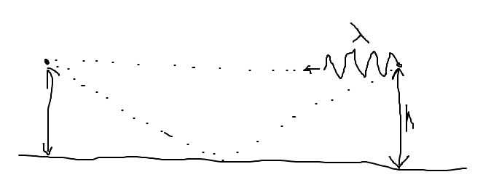
The wavelength of signal is
$λ=c/f=\left(3.0×{10}^{8} m/s\right)/\left(200×{10}^{6} Hz\right)=1.5 m$
We know that the two waves (one reflecting, one direct) destructively interfere at the receiver; since the reflected wave takes on $π$-radian phase shift upon reflection ($n_{water}>n_{air}$), thus the destructive interference occurs when the difference in optical path length is an integer multiple of $λ$, i.e.
$\sqrt{d^{2}+{\left(2h\right)}^{2}}-d=mλ, m∈Z$
Which, upon approximation $h≪d$:
$mλ=d\left(\sqrt{1+{\left(\frac{2h}{d}\right)}^{2}}-1\right)≈d⋅\frac{1}{2}{\left(\frac{2h}{d}\right)}^{2}=\frac{2h^{2}}{d}∴d=\frac{2h^{2}}{mλ}$
which gives us
${d|}_{m=1}=\frac{2⋅{20}^{2}}{1⋅1.5}=\frac{1600}{3} m≈533 m$
Equivalently, one can imagine a double slit experiment where
- the two transmitters are separated by $a=2h$
- the screen is distance $d$ from the transmitters
- the point of interest is at distance $h$ from the centre
applying $asinsin θ =\left(2h\right)\left(h/L\right)=mλ$ also arrives at the same ${d|}_{m=1}$.
(ii) Distance between the two minima is
$Δx={d|}_{m=1}-{d|}_{m=2}=\frac{2⋅{20}^{2}}{1⋅1.5}-\frac{2⋅{20}^{2}}{2⋅1.5}=\frac{800}{3} m$
The speed of the boat is
$v=Δx/t=\frac{800}{3}/50=\frac{16}{3} m/s≈5.33 m/s$
8) (a) Dimensional analysis
$\left[a\right]=\left[P\right]{\left[V\right]}^{2}=\left(kg⋅m^{-1}⋅s^{-2}\right){\left(m^{3}\right)}^{2}=kg⋅m^{5}⋅s^{-2}$
$\left[b\right]=\left[V\right]=m^{3}$
(b) At boiling point,
${\left(\frac{∂P}{∂V}\right)}_{T}=0$
(intuitively, when vaporisation/condensation occurs at the boiling point, there is instantaneous significant increase in volume at a fixed temperature and pressure for the phase change to occur)
We can apply this to ${\left(\frac{∂}{∂V}\right)}_{T}$ of the Van der Waal equation:
$\left({\left(\frac{∂P}{∂V}\right)}_{T}-\frac{2a}{V^{3}}\right)\left(V-b\right)+\left(P+\frac{a}{V^{2}}\right)\left(1\right)=0$
$∴P_{boil}=\frac{2a\left(V-b\right)}{V^{3}}-\frac{a}{V^{2}}=\frac{aV-2ab}{V^{3}}$
The maximal pressure for which a boiling point exists is at maximum $P_{boil}$. This is achieved at
$\frac{dP_{boil}}{dV}=0∴\frac{d}{dV}\left(\frac{aV-2ab}{V^{3}}\right)=\frac{aV^{3}-3V^{2}\left(aV-2ab\right)}{V^{6}}=0∴-2V^{2}+6bV^{2}=0$
which gives the solution $V_{c}=3b$. We calculate the corresponding
$P_{c}=\frac{aV_{c}-2ab}{{V_{c}}^{3}}=\frac{3ab-2ab}{{\left(3b\right)}^{3}}=\frac{a}{27b^{2}}$
and
$T_{c}=\frac{1}{R}\left(P_{c}+\frac{a}{{V_{c}}^{2}}\right)\left(V_{c}-b\right)=\frac{1}{R}\left(\frac{a}{27b^{2}}+\frac{a}{9b^{2}}\right)\left(3b-b\right)=\frac{8a}{27Rb}$
9) (a) We note that
- $Δx$ is an arbitrary unit for the width of an element of air
- $s=Δs$ is the difference in the displacement between left and right of the element of air.
Applying Newton’ Law:
$F_{net}=Ap_{left}-A_{right}=AΔp=A\left(-B\frac{ΔV}{V}\right)=m\ddot{s}$
$∴m\ddot{s}+AB\frac{As}{AΔx}=0∴\ddot{s}+\frac{AB}{mΔx}s=0∴ω^{2}=\frac{AB}{mΔx}$
(angular frequency of the small-oscillation)
$v^{2}={\left(ωΔx\right)}^{2}=\frac{ABΔx}{m}=\frac{B}{ρ}∴ρv^{2}=B$
(b) We have
$λ=4L;v=fλ∴λ=vT∴T=\frac{4L}{v}$
$L=9.0×{10}^{-3}⋅6.955×{10}^{8} m$
$v=\sqrt{B/ρ }=\sqrt{1.33×{10}^{22}/{10}^{10}}=1.15×{10}^{6} m/s$
substituting in: $T=21.8 s$
10) Apply Compton scattering $λ^{'}-λ=\frac{h}{M_{0}c}\left(1-coscos θ \right)$
we know the initial photon has energy $E=hc/λ$ and after rebounding, leaves with energy $E^{'}=hc/λ^{'}$. In order to maximise the kinetic energy of the recoiling electron, $KE=E-E^{'}$ (by conservation of energy), we must have minimum $E^{'}$ which occurs at maximum $λ^{'}$, in turn occurring when $coscos θ$ is minimum ($coscos θ =-1∴θ=π$) thus:
$λ^{'}-λ=\frac{2h}{M_{0}c}$
$KE_{max}=E-E^{'}=E-\frac{hc}{λ^{'}}=E-\frac{hc}{\frac{2h}{M_{0}c}+λ}=E-\frac{hc/λ}{2\left(hc/λ\right)/\left(M_{0}c^{2}\right)+1}=E-\frac{E}{\frac{2E}{M_{0}c^{2}}+1}=E-\frac{EM_{0}c^{2}}{2E+M_{0}c^{2}}=\frac{2E^{2}}{2E+M_{0}c^{2}}$

SPhO 2008
1) Direct application of kinematics
$v\left(t\right)=v\left(0\right)+\int_{0}^{t}{}a\left(t\right)dt=u+\int_{0}^{t}{}kt^{2}dt=u+{\left[\frac{1}{3}kt^{3}\right]}_{0}^{t}=u+\frac{1}{3}kt^{3}$
$x\left(t\right)=\int_{0}^{t}{}v\left(t\right)dt=\int_{0}^{t}{}\left(u+\frac{1}{3}kt^{3}\right)dt={\left[ut+\frac{1}{12}kt^{4}\right]}_{0}^{t}=ut+\frac{1}{12}kt^{4}$
as desired.

2) (a) Consider torque on beam about the pivot.
$τ_{net}=0∴T\left(6.00 m\right)sinsin 60.0° =\left(700 N\right)\left(1.00 m\right)+\left(200 N\right)\left(3.00 m\right)+\left(80.0 N\right)\left(6.00 m\right)=1780 Nm$
solving, $T=343 N$
(b) Similarly,
$T\left(6.00 m\right)sinsin 60.0° =\left(700 N\right)\left(x m\right)+\left(200 N\right)\left(3.00 m\right)+\left(80.0 N\right)\left(6.00 m\right)T=\frac{2\left(700x+1080\right)}{6\sqrt{3}} N≤900 N∴x≤5.14$
The bear can walk a maximum of $5.14 m$ before the wire breaks.

3) We take the length of falling chain as a system. When a length $l$ has fallen, the system has mass $m=M\left(1-l/L\right)$ and travelling at speed $v=\sqrt{2gl}$. Applying Newton’s Law:
$W-N=mg-N=\frac{d\left(mv\right)}{dt}=m\frac{dv}{dt}+v\frac{dm}{dt}=mg-\frac{vM}{L}\frac{dl}{dt}=mg-\frac{v^{2}M}{L}$
$∴ N=\frac{v^{2}M}{L}=\frac{2Mgl}{L}$
The reading on the scale is equal to the normal force exerted on the falling chain, plus the normal force exerted on the links already at rest on the scale:
$F=N+M\left(l/L\right)g=\frac{3Mgl}{L}$
4) (a) The velocity of the electrons are $v=\sqrt{2E/m}$ and the magnetic field exerts a force $F=qvB$ perpendicular to velocity, causing uniform circular motion of radius $r=mv^{2}/F$. Putting it all together:
$r=\frac{mv}{qB}=\frac{\sqrt{2mE}}{qB}=\frac{\sqrt{2\left(9.11×{10}^{-31}\right)\left(2×{10}^{14}×1.6×{10}^{-19}\right)}}{\left(1.6×{10}^{-19}\right)\left(2×{10}^{-8}\right)}=2.39×{10}^{9} m$
We can express this as $r=\frac{2.386×{10}^{9}}{6.4×{10}^{6}} R_{E}=373R_{E}$ (373 times the radius of the Earth!)
(b) $T=\frac{2πr}{v}=\frac{2πm}{qB}=\frac{2π\left(9.11×{10}^{-31}\right)}{\left(1.6×{10}^{-19}\right)\left(2×{10}^{-8}\right)}=1.79×{10}^{-3} s$
Since $1 day=24×60×60 s=86400 s$ thus
$T=1.79×{10}^{-3}/86400=2.07×{10}^{-8} Earth days$
5) (a) Conservation of energy, $ΔK=\frac{GMm}{r_{i}}-\frac{GMm}{r_{f}}$
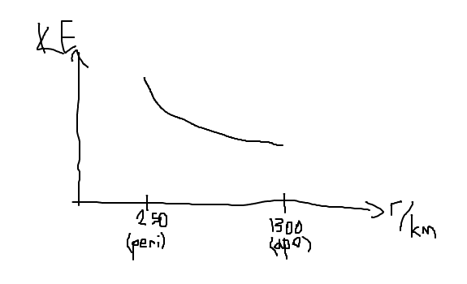
(b) We know that $mv_{a}r_{a}=mv_{p}r_{p}$ (Conservation of angular momentum; the velocities at perigee and apogee are perpendicular to the major axis, and thus perpendicular to the position vector from the Earth)
$∴v_{a}=\frac{r_{p}}{r_{a}}v_{p}=\frac{250}{1300}v_{p}$
(c) Conservation of energy $\frac{1}{2}mv_{a}^{2}-\frac{GMm}{r_{a}}=\frac{1}{2}mv_{p}^{2}-\frac{GMm}{r_{p}}$
$v_{a}\left(\frac{{1300}^{2}}{{250}^{2}}-1\right)=2GM\left(\frac{1}{r_{p}}-\frac{1}{r_{a}}\right)=2\left(6.67×{10}^{-11}\right)\left(6×{10}^{24}\right)\left(\frac{1}{2.5×{10}^{5}}-\frac{1}{1.3×{10}^{6}}\right)$
Solving,
$v_{a}=9.93×{10}^{7}m/s$
6) (a) $dp=-ρg dy;ρ=\frac{m}{V}=\frac{nM}{V}=\frac{pM}{RT}∴dp=-\frac{pMg}{RT}dy$
$∴\int_{p_{0}}^{p\left(y\right)}{}\frac{dp}{p}=\int_{0}^{y}{}\frac{-Mg}{RT}dy=\int_{0}^{y}{}\frac{-Mg}{R\left(T_{0}-αy\right)}dy$
$∴{\left[lnln p \right]}_{p_{0}}^{p\left(y\right)}={\left[\frac{Mg}{Rα}lnln \left(T_{0}-αy\right) \right]}_{0}^{y}∴lnln \frac{p\left(y\right)}{p_{0}} =\frac{Mg}{Rα}lnln \frac{T_{0}-αy}{T_{0}} =\frac{Mg}{Rα}lnln \left(1-\frac{αy}{T_{0}}\right)$
$∴p\left(y\right)=p_{0}{\left(1-\frac{αy}{T_{0}}\right)}^{Mg/Rα}$
(b) In the limit $α→0$:
$p\left(y\right)=p_{0}{\left(1-\frac{αy}{T_{0}}\right)}^{Mg/Rα} =p_{0}p_{0}{\left(1-x\right)}^{\frac{1}{x}⋅Mgy/RT_{0}} \left(x=\frac{αy}{T_{0}}\right)$
${\left(1-x\right)}^{\frac{1}{x}} =\frac{1}{e}∴p\left(y\right)=p_{0}{\left({\left(1-x\right)}^{\frac{1}{x}} \right)}^{Mgy/RT_{0}}=p_{0}e^{-MGg/RT_{0}}$
Which we can verify to satisfy the differential equation $dp=-\frac{pMg}{RT_{0}}dy$.
(c) Substituting into expression in part a (since air is mostly nitrogen, we know $M≈28 g/mol=0.028 kg/mol$):
$p=\left(1\right){\left(1-\frac{\left(6×{10}^{-3}\right)\left(8863\right)}{300}\right)}^{\frac{0.028⋅9.81}{8.314⋅6×{10}^{-3}}}=0.34 atm$
7) The two events of interest $\left(x,ct\right)$ in frame S are $P: \left(x_{1},0\right)$ and $Q: \left(x_{2},cΔt\right)=\left(x_{1}+l,l\right)$. We apply Lorentz transformation
$\{x^{'}=γ\left(x-bct\right) ct^{'}=γ\left(ct-bx\right)$
Thus
$P^{'}:\left(γx_{1}, -γbx_{1}\right)$
$Q^{'}:\left(γx_{1}+γl-γbl, γl-γbx_{1}-γbl\right)$
The separation in S’ frame is thus
$l^{'}=\left(γx_{1}+γl-γbl\right)-γx_{1}=γ\left(1-b\right)l=\frac{1-b}{\sqrt{1-b^{2}}}l=l\sqrt{\frac{1-b}{1+b}}$
and time interval is
$cΔt^{'}=\left(γl-γbx_{1}-γbl\right)—γbx_{1}=γ\left(1-b\right)l=l^{'}∴Δt^{'}=\frac{l^{'}}{c}=\frac{l}{c}\sqrt{\frac{1-b}{1+b}}$
8) Draw the free-body diagram:
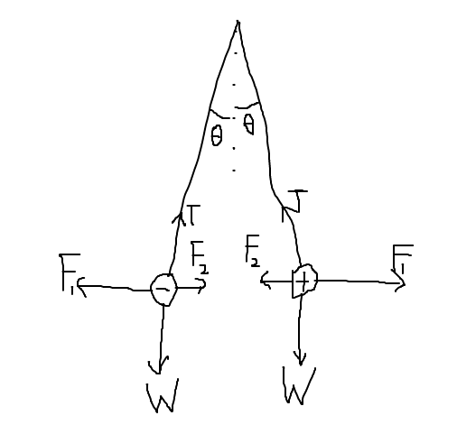
Where $W=mg, F_{1}=qE, F_{2}=\frac{kq^{2}}{d^{2}}=\frac{1}{4πϵ_{0}}⋅\frac{q^{2}}{{\left(2lsinsin θ \right)}^{2}}$
Resolving forces perpendicular to the string:
$\left(F_{1}-F_{2}\right)coscos θ -Wsinsin θ =0∴F_{1}=qE=F_{2}+Wtantan θ$
$E=\frac{1}{q}\left(\frac{1}{4πϵ_{0}}⋅\frac{q^{2}}{{\left(2lsinsin θ \right)}^{2}}+mgtantan θ \right)$
substituting in $q=5.00×{10}^{-8}C, m=0.00200 kg, l=0.100 m, θ=10.0°$:
$E=\frac{1}{5.00×{10}^{-8}}\left(\frac{{\left(5.00×{10}^{-8}\right)}^{2}}{4π\left(8.85×{10}^{-12}\right){\left(2⋅0.100sinsin 10.0° \right)}^{2}}+0.00200⋅9.81tantan 10.0° \right)=0.0221 V/m$
9) We know that by direct application of Ampere’s Law (circular loop of radius x around the wire), the magnetic field a distance x from the wire is $B\left(r\right)=\frac{μ_{0}I}{2πx}$. Thus $ε=\frac{dϕ}{dt}=\frac{d}{dt}\left(BA\right)=v\int_{r}^{l+r}{}B\left(x\right) dx=v\int_{r}^{l+r}{}\frac{μ_{0}I}{2πx}dx$
$=\frac{μ_{0}vI}{2π}\int_{r}^{l+r}{}\frac{dx}{x}=\frac{μ_{0}vI}{2π}lnln \frac{l+r}{r} =\frac{μ_{0}vI}{2π}lnln \left(1+\frac{l}{r}\right)$
and the constant is $κ=\frac{μ_{0}}{2π}=2×{10}^{-7} H/m$
10) The optical path length of the pit is$Δx=nd=\frac{λ}{4}$. Thus
$d=\frac{λ}{4n}=\frac{780}{4⋅1.50}=130 nm$

SPhO 2009
1) We first visualise the mechanics.
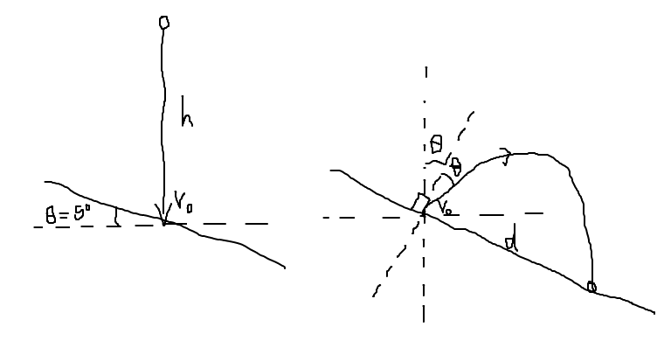
The ball hits the inclined plane at velocity $v_{0}=\sqrt{2gh}$. Because collision is elastic, it rebounds off at the same angle $θ$ relative to the normal to the plane, with the same velocity $θ$. (note for inelastic collisions, $v_{⊥f}=-\sqrt{e}v_{⊥i}, v_{∥f}=v_{∥i}$)

The ball then undergoes free-fall again; it is helpful to see that the perpendicular component has constant acceleration $-gcoscos θ$ while parallel component has constant acceleration $gsinsin θ$. Thus:
$t=\frac{2v_{⊥}}{a_{⊥}}=\frac{2v_{0}coscos θ }{gcoscos θ }=\frac{2v_{0}}{g}$
and
$d=v_{∥}t+\frac{1}{2}a_{∥}t^{2}=\left(v_{0}sinsin θ \right)\left(\frac{2v_{0}}{g}\right)+\frac{1}{2}\left(gsinsin θ \right){\left(\frac{2v_{0}}{g}\right)}^{2}=\frac{4{v_{0}}^{2}}{g}sinsin θ =8hsinsin θ$
Substituting $h=1 m, θ=5°$:
$d=8\left(1\right)sinsin 5° =0.697 m$
2) Visualisation of the problem is key.
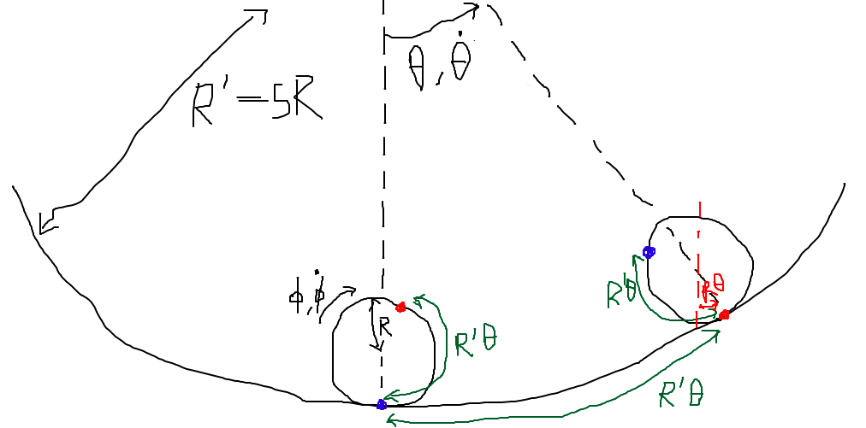
From this image we can see
$R^{'}θ=Rθ+Rϕ∴ϕ=\left(\frac{R^{'}}{R}-1\right)θ∴\dot{ϕ}=\left(\frac{R^{'}}{R}-1\right)\dot{θ}, \ddot{ϕ}=\left(\frac{R^{'}}{R}-1\right)\ddot{θ}$
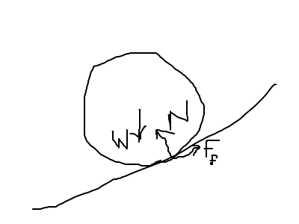
Note the centre of mass of the ball moves in an arc of radius $R^{'}-R$. Thus
$F_{net\left(∥\right)}=F_{f}-Wsinsin θ =F_{f}-mgsinsin θ =ma=m\left(R^{'}-R\right)\ddot{θ}$
and
$τ_{net}=-F_{f}R=I\ddot{ϕ}=\frac{2}{5}mR^{2}\ddot{ϕ}$
thus
$mgsinsin θ +\frac{2}{5}mR\ddot{ϕ}+m\left(R^{'}-R\right)\ddot{θ}=0$
small angle approximation $sinsin θ ≈θ$:
$θ+\frac{7\left(R^{'}-R\right)}{5g}\ddot{θ}=0∴ω=\sqrt{\frac{7\left(R^{'}-R\right)}{5g}}∴T=\frac{2π}{ω}=2π\sqrt{\frac{5g}{7\left(R^{'}-R\right)}}$
finally, substitute $R^{'}=5R$:
$T=π\sqrt{\frac{5g}{7R}}$
Alternatively, one can note that the kinetic energy of the ball is
$K=\frac{1}{2}mv^{2}+\frac{1}{2}I{\dot{ϕ}}^{2}=\frac{1}{2}m{\left(\left(R^{'}-R\right)\dot{θ}\right)}^{2}+\frac{1}{2}\left(\frac{2}{5}mR^{2}\right){\left(\frac{R^{'}-R}{R}\dot{θ}\right)}^{2}=\frac{7}{10}m{\left(R^{'}-R\right)}^{2}{\dot{θ}}^{2}$
$U=mg\left(R^{'}-R\right)\left(1-coscos θ \right)≈mg\left(R^{'}-R\right)⋅\frac{θ^{2}}{2}=\frac{1}{2}mg\left(R^{'}-R\right)θ^{2}$
thus
$ω=\sqrt{\frac{\frac{1}{2}mg\left(R^{'}-R\right)}{\frac{7}{10}m{\left(R^{'}-R\right)}^{2}}}$
which gives us the same result.
3) (i) Drawing the ray diagram:
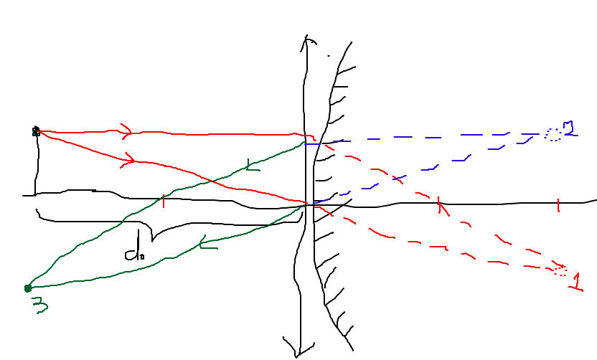
From the ray diagram, we see that the final image is real and 40cm from the lens (aligned with the initial object), but inverted. By using the mirror/lens equations (1/40+1/40=1/20), we can check our result rigorously:
- The first image (after passing through the converging lens) is fictitious, inverted and 40cm into the lens.
- The second image (upon reflection from diverging mirror) is fictitious, upright and 40cm into the lens.
- The final image (after passing through the converging lens again) is real, 40cm from the lens, and inverted.
(ii) We have to redraw the scenario:
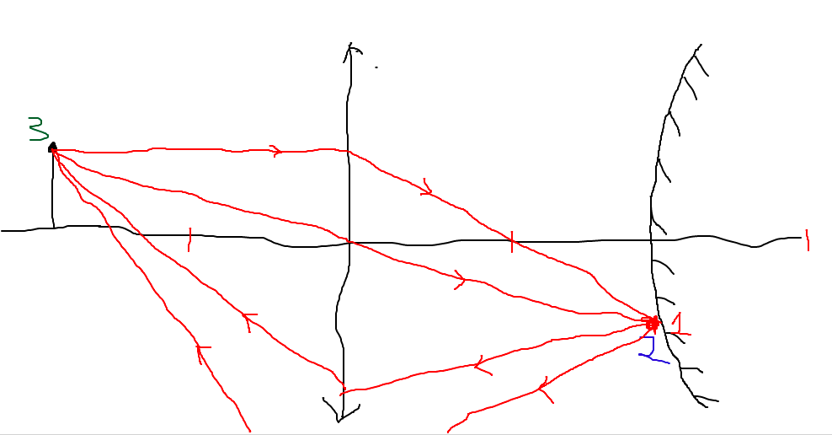
The final image is at the exact same position as the object (real, upright at 40cm from the lens). We can trace that
- The first image (after passing through the converging lens) is fictitious, inverted and 40cm into the lens.
- The second image (upon reflection from diverging mirror) is the exact same position as the first image because the first image is on the mirror plane.
- The final image (after passing through the converging lens again) is as given above.

4) It is reasonable to assume $h_{0}≪L$ (the star is very far away) but we should not assume $h≪L$ (since the star may potentially rise comparably high for the first minimum).
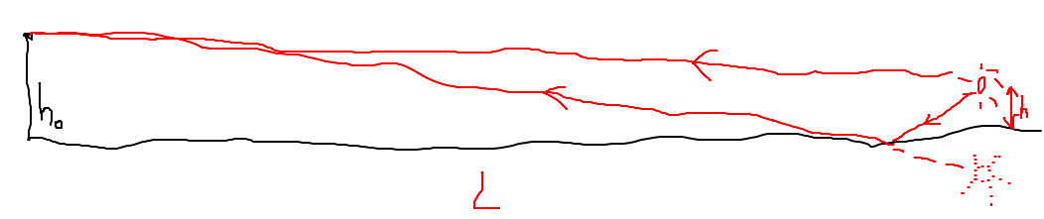
Note the reflected ray picks up a $π$-radian phase shift upon reflection at the water-air boundary. By treating the scenario as a double-slit interference experiment where the sources (separated by $d=2h$) are anti-phase, we find that the condition for minimum light received (which is when destructive interference occurs) is
$d⋅\frac{h_{0}}{L}=mλ, m∈N$
Since the angle of the star above the horizon is $θ_{star}=arctanarctan \frac{h}{L}$ (small-angle approximation) thus we have
$θ_{star}=arctanarctan \frac{mλ}{2h_{0}}$
the first minimum is when $m=1$ thus
$θ_{star}≈arctanarctan \frac{λ}{2h_{0}} =arctanarctan \frac{c/f}{2h_{0}} =arctanarctan \frac{\left(2.997×{10}^{8}\right)/\left(1.5×{10}^{9}\right)}{2\left(0.50\right)} =0.197 rad≈0.20 rad$

5) (i) We know that
$KE_{max}=E_{photon}-ϕ=hf-ϕ=\frac{hc}{λ}-ϕ$
where $ϕ$ is the work function of the metal. Thus
$KE_{max}=\frac{\left(6.63×{10}^{-34}\right)\left(2.997×{10}^{8}\right)}{\left(400×{10}^{-9}\right)\left(1.6×{10}^{-19}\right)}-2.25=0.8547 eV≈0.85 eV$
(ii) The number of electrons emitted per square meter per second from the surface is
$\frac{n}{AΔt}=\frac{η⋅\left(E/E_{photon}\right)}{AΔt}=\frac{η}{E_{photon}}⋅\frac{P}{A}=\frac{Iηλ}{hc}$
where $η$ is the efficiency. This is evaluated as
$\frac{\left(3×{10}^{-9}\right)\left(0.03\right)\left(400×{10}^{-9}\right)}{\left(6.63×{10}^{-34}\right)\left(2.997×{10}^{8}\right)}=1.81×{10}^{8} electrons⋅m^{-2}s^{-1}$

6) (i) Conservation of energy! It trajectory is confined to a radial ray, so at maximum height it is completely stationary:
$\frac{1}{2}m{v_{i}}^{2}=\frac{GMm}{R_{E}}-\frac{GMm}{r_{f}}=\frac{GMm}{R_{E}}-\frac{GMm}{R_{E}+h}=\frac{GMmh}{R_{E}\left(R_{E}+h\right)}$
The escape velocity is exactly when $h→∞, v_{i}→v_{esc}$ thus
$\frac{1}{2}m{v_{esc}}^{2}=\frac{GMm}{R_{E}}$
because $\frac{h}{R_{E}+h} =1$. Therefore
$\frac{1}{2}m{v_{i}}^{2}=\frac{1}{2}m{v_{esc}}^{2}⋅\frac{h}{R_{E}+h}∴\left(R_{E}+h\right){v_{i}}^{2}=h{v_{esc}}^{2}∴h=\frac{R_{E}{v_{i}}^{2}}{{v_{esc}}^{2}-{v_{i}}^{2}}$
(ii) We simply need to substitute into the expression in (i):
$h=\frac{R_{E}{v_{i}}^{2}}{{v_{esc}}^{2}-{v_{i}}^{2}}=\frac{\left(6.4×{10}^{6}\right){\left(8.76\right)}^{2}}{{11.2}^{2}-{8.76}^{2}}=1.0×{10}^{7} m$
(iii) We observe that a stone thrown vertically upward with the same speed will cause the meteorite to rise to the same height (in other words, Newtonian mechanics is time-reversal invariant). Note the equation in (i) can be rearranged to
${v_{i}}^{2}=\frac{{v_{esc}}^{2}h}{R_{E}+h}∴v_{i}=v_{esc}\sqrt{\frac{h}{R_{E}+h}}=\left(11.2\right)\sqrt{\frac{2.51×{10}^{7}}{6.4×{10}^{6}+2.51×{10}^{7}}}=10.0 km/s$
(iv) Because initial speed is small, we can assume the ball doesn’t fly very high, and gravitational acceleration can be assumed to be constant at $g$. Thus by conservation of energy,
$KE_{i}=\frac{1}{2}m{v_{i}}^{2}=GPE_{peak}=mgh∴h=\frac{{v_{i}}^{2}}{2g}$
Alternatively, we can use kinematics for constant acceleration,
$t=\frac{v_{i}}{g}, h=\frac{1}{2}gt^{2}=\frac{1}{2}g{\left(\frac{v_{i}}{g}\right)}^{2}=\frac{{v_{i}}^{2}}{2g}$
We compare this to the equation in part (i), where we take the limit $\frac{v_{i}}{v_{esc}}→0$ (because $v_{i}≪v_{esc}$):
$h=\frac{R_{E}{v_{i}}^{2}}{{v_{esc}}^{2}-{v_{i}}^{2}}=\frac{R_{E}{v_{i}}^{2}}{{v_{esc}}^{2}\left(1-{\left(v_{i}/v_{esc}\right)}^{2}\right)}→\frac{R_{E}{v_{i}}^{2}}{{v_{esc}}^{2}}=\frac{{v_{i}}^{2}}{{v_{esc}}^{2}/R_{E}}$
this is consistent because
$\frac{{v_{esc}}^{2}}{R_{E}}=\frac{{\left(11.2×{10}^{3}\right)}^{2}}{6.4×{10}^{6}}=19.6 m/s=2⋅9.8 m/s=2g$
7) We label the nodes.
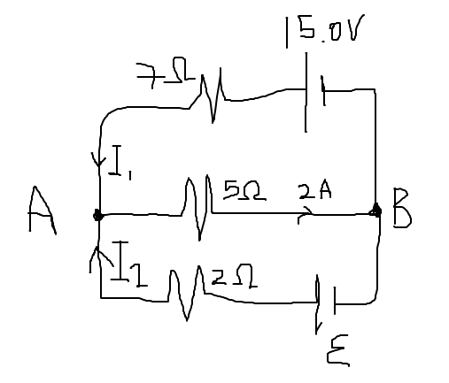
We have that
$V_{AB}=\left(5.00Ω\right)\left(2A\right)=10.0V=15.0V-\left(7.00Ω\right)I_{1}=ε-\left(2.00Ω\right)I_{2}$
and by Kirchoff’s Current Law on node A:
$I_{1}+I_{2}=2A$
We simply solve the variables one by one:
- $I_{1}=\frac{15.0V-V_{AB}}{7.00Ω}=\frac{5}{7}A≈0.714A$
- $I_{2}=2A-I_{1}=\frac{9}{7}A≈1.286A$
- $ε=V_{AB}+\left(2.00Ω\right)I_{2}=12.6V$
8) The amount of heat needed to warm mass $m_{w}$ of water and mass $m_{g}$ of glass from $T_{i}=20.0°C$ to $θ$ is
$Q=\left(m_{w}c_{w}+m_{g}c_{g}\right)ΔT=\left(m_{w}c_{w}+m_{g}c_{g}\right)\left(θ-T_{i}\right)$
The amount of heat lost to cool mass $m_{s}$ of steam from $T_{s}=130°C$ to $θ$ is
$Q=m_{s}c_{s}\left(T_{s}-T_{boil}\right)+m_{s}L_{vap}+m_{s}c_{w}\left(T_{boil}-θ\right)$
where we implicitly assume $θ≤100°C$ (so that all steam condenses).

Equating the heat transfer:
$\left(m_{w}c_{w}+m_{g}c_{g}\right)\left(θ-T_{i}\right)=m_{s}\left[c_{s}\left(T_{s}-T_{boil}\right)+L_{vap}+c_{w}\left(T_{boil}-θ\right)\right]$
thus the mass of steam required can be expressed as
$m_{s}=\frac{\left(m_{w}c_{w}+m_{g}c_{g}\right)\left(θ-T_{i}\right)}{c_{s}\left(T_{s}-T_{boil}\right)+L_{vap}+c_{w}\left(T_{boil}-θ\right)}$
We evaluate it at the two temperatures desired by the question:
(i) $θ=100°C$
$m_{s}=\frac{\left(200⋅4.19+100⋅0.837\right)\left(100-20.0\right)}{2.01\left(130-100\right)+2260+4.19\left(100-100\right)}=31.78 g$
(i) $θ=50°C$
$m_{s}=\frac{\left(200⋅4.19+100⋅0.837\right)\left(50-20.0\right)}{2.01\left(130-100\right)+2260+4.19\left(100-50\right)}=10.93 g$
9) (i) We have the equation of motion
$F⃑=\left(-e\right)E⃑+\left(-e\right)v⃑×B⃑=m_{e}a⃑$
and we know
$E⃑=\left(0 -E 0 \right), B⃑=\left(0 0 -B \right)$
thus
$\left(0 eE 0 \right)+\left(ev_{y}B -ev_{x}B 0 \right)=\left(m_{e}\dot{v_{x}} m_{e}\dot{v_{y}} 0 \right)∴\{v_{y}=\frac{m_{e}}{eB}\dot{v_{x}} v_{x}=\frac{E}{B}-\frac{m_{e}}{eB}\dot{v_{y}} ∴\{v_{y}=-{\left(\frac{m_{e}}{eB}\right)}^{2}\ddot{v_{y}} v_{x}=\frac{E}{B}-{\left(\frac{m_{e}}{eB}\right)}^{2}\ddot{v_{x}}$
$∴\{v_{y}+{\left(\frac{m_{e}}{eB}\right)}^{2}\ddot{v_{y}}=0 v_{x}+{\left(\frac{m_{e}}{eB}\right)}^{2}\ddot{v_{x}}=\frac{E}{B}$
(ii) which are the familiar SHM equations with solutions (where $ω=\frac{eB}{m_{e}}$)
$\{v_{x}=\frac{E}{B}-Acoscos \left(ωt+ϕ\right) v_{y}=\frac{m_{e}}{eB}\dot{v_{x}}=Asinsin \left(ωt+ϕ\right)$
and solving for $A, ϕ$ with the initial conditions $v_{x}\left(0\right)=v_{y}\left(0\right)=0$:
$\{v_{x}=\frac{E}{B}\left(1-coscos ωt \right) v_{y}=\frac{E}{B}sinsin ωt$
And taking into account $x\left(0\right)=y\left(0\right)=0$:
$\{x\left(t\right)=\int_{0}^{t}{}v_{x} dt=\int_{0}^{t}{}\frac{E}{B}\left(1-coscos ωt \right) dt=\frac{E}{B}\left(t-\frac{1}{ω}sinsin ωt \right)=\frac{E}{B}\left(t-\frac{m_{e}}{eB}sinsin \frac{eBt}{m_{e}} \right) y\left(t\right)=\int_{0}^{t}{}v_{y} dt=\int_{0}^{t}{}\frac{E}{B}sinsin ωt dt=\frac{E}{Bω}\left(1-coscos ωt \right)=\frac{m_{e}E}{eB^{2}}\left(1-coscos \frac{eBt}{m_{e}} \right)$
(iii) The maximum value of $y$ is when the cosine takes value $-1$, and
$y_{max}=\frac{m_{e}E}{eB^{2}}\left(1-\left(-1\right)\right)=\frac{2m_{e}E}{eB^{2}}$
(iv) The value of $a$ is when $y$ repeats its period, which is when $\frac{eBt}{m_{e}}=2π$ thus
$a=x\left(\frac{2πm_{e}}{eB}\right)=\frac{E}{B}⋅\frac{2πm_{e}}{eB}=\frac{2πm_{e}E}{eB^{2}}$
10) The rod is moving at $β=0.995$. The component lengths perpendicular to motion are unchanged by relativistic effects, while parallel component undergoes length contraction. Thus if we break the rod into its components lengths $x$ and $y$, we have
$\{x=\frac{x^{'}}{γ}=2.00coscos 30.0° =\sqrt{3} m y=y^{'}=2.00sinsin 30.0° =1.00 m$
In the proper frame $S’$:
$x^{'}=γx=\frac{x}{\sqrt{1-β^{2}}}=\frac{\sqrt{3}}{\sqrt{1-{0.995}^{2}}}=17.34 m$
And the rod has proper length
$L_{proper}=\sqrt{{x^{'}}^{2}+{y^{'}}^{2}}=\sqrt{{17.34}^{2}+{1.00}^{2}}=17.37 m$
at orientation angle
$θ^{'}=arctanarctan \frac{y^{'}}{x^{'}} =arctanarctan \frac{1.00}{17.34} =0.0576 rad=3.30°$

